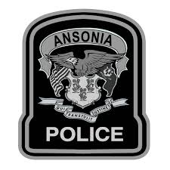
PRE-ENROLLMENT PISTOL PERMIT PROCESS

Applicants are to complete and provide the following documents which are required to start the pistol permit process. This includes:
- Notarized Pistol Permit Application
- FBI Privacy Act Form
- Noncriminal Justice Applicant’s Privacy Rights Form
- Agency Privacy Requirements for Noncriminal Justice Applicants Form
- Certified Copy, with raised seal, Birth Certificate must be included
- Letter from valid State Certified instructor must be included
- Most recent passport photograph of applicant must be included
- One money order, personal check, or certified check made payable to: Ansonia Police Department for $70.00 for the Ansonia Police Department Processing Fee
- Self-Addressed stamped envelope

The applicant must then submit all of the above paperwork to the Ansonia Police Department.

The dispatcher on duty will then provide a Pistol Permit Service Code to the applicant to complete the next step on https://ct.flexcheck.us.idemia.io/cchrspreenroll.

After all of these steps are complete, the applicant will then schedule an appointment to be fingerprinted.
Upon completion, an APPLICANT TRACKING NUMBER will be generated which you will need to print out along with the PRE-ENROLLMENT CONFIRMATION in order to be fingerprinted.
If the Pre-Enrollment process is not completed and both pieces of paperwork are not provided to a police officer you will be turned away from being fingerprinted until this part of the process is complete.

*RESIDENTS MUST/CAN ONLY GET FINGERPRINTED AT THE ANSONIA POLICE DEPARTMENT FOR ANSONIA PERMITS*

*The Ansonia Police Department will not accept fingerprints from residents who have been fingerprinted from another Police Department*

