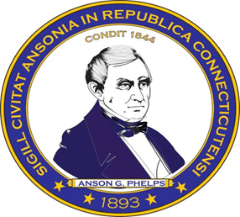
City of Ansonia
Request for Qualifications (RFQ) & Proposals (RFP)
31-165 Olson Drive – Environmental Services
February 21, 2024

The City of Ansonia is issuing this Request for Qualifications (RFQ) and Request for Proposal (RFP) to retain a qualified firm to complete environmental assessment and remedial planning for the site located at 31-165 Olson Drive.
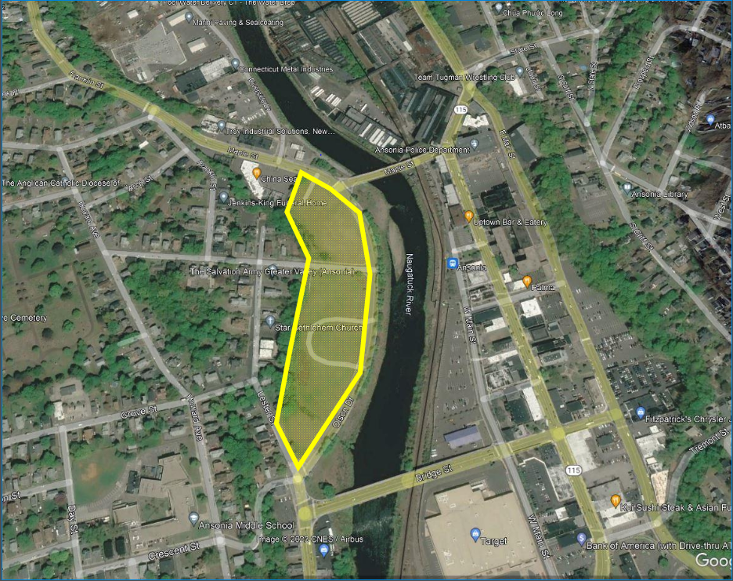
The City of Ansonia was awarded a Brownfield Remediation Grant from the Connecticut Department of Economic and Community Development (CT DECD) to remediate and redevelop the property located at 31-165 Olson Drive into a multi-sport complex with two buildings, a soccer field and asphalt-paved parking areas. The intent of this RFQ/RFP is to select a consultant who is qualified to perform environmental assessments and oversight to guide the remediation in conjunction with the development of the site.
There will not be a public opening of this bid.
MBE’s, WBE’s and SBE’s are encouraged to apply.
An affirmative action/equal opportunity employer

Deadline for the proposal is 1pm, Wednesday, March 6, 2024. The Respondent’s submittal shall be one single PDF emailed to the following:
Town and City Clerk
℅ Diana Branch
City of Ansonia
253 Main Street
Ansonia, CT 06401
somalley@ansoniact.org
All questions must be submitted by 3:00 PM on Tuesday February 27, 2024. Questions must be submitted by email to the Economic Development Director at somalley@ansoniact.org. All questions determined to be of interest to all prospective firms will be answered in writing by an addendum, which will be posted on the City’s website. It is the responsibility of potential bidders to check the website for addendum(s). Interested firms should check the website 48 hours before the closing date.
This RFQ/RFP does not commit the City of Ansonia to select any Respondent or enter into any contract agreement. The City of Ansonia reserves the right, in its sole discretion, to accept or reject any or all RFQ/RFPs; to waive any informalities, reissue a subsequent RFQ/RFP, terminate, restructure or amend this procurement process at any time. The City of Ansonia reserves the right to accept any proposal deemed in the best interests of the City of Ansonia.
The City will not be liable for any costs incurred by a firm in preparation or submission of a proposal.
The information provided herein is not intended to and shall not bind the City of Ansonia to any of the statements or assumptions set forth herein.
Evaluation criteria contained herein shall be used in evaluating qualifications. The City may contact any consultant after receiving its submittal to seek clarification of any portion thereof. The City reserves the right to request additional information from any consultant if the City deems such information necessary to further evaluate the consultant’s qualifications. In the event the City elects to negotiate a contract with a selected consultant, the City reserves the right to negotiate such terms and conditions of the contract, including, but not limited to scope, role, and price and staffing which may be in the best interests of the City.
All work is expected to occur during the next 12 months. Consultants must demonstrate the ability to start work immediately upon contract execution. Any contract entered into by the City and the successful bidder shall provide that the City may terminate the contract upon thirty (30) days’ notice to the bidder. The information provided herein is not intended to and shall not bind the City of Ansonia to any of the statements or assumptions set forth herein.
Submittal Requirements
In your submittal, the City is requesting the following:
- The Scope of Services for site assessment and remedial planning in accordance with the requirements of the project.

- Consultant’s Qualifications and Capabilities: Describe the qualifications and capabilities of the consultant as they relate to the management of brownfield projects and grants, and the demonstrated ability to provide services on multiple projects and perform technical oversight of multiple subcontractors. Emphasis should be on site assessment, remedial planning, brownfields consulting and the ability to conduct all services in-house.

- Past Project Experience: Include project summaries of relevant brownfield projects completed in the State of Connecticut and EPA Region 1 by the firm. Summarize the Scope of Services, and provide client contact information (no less than 3 references).

- Key Staff Assigned to the Project: Identify specific personnel that will be assigned to the following key roles for the project: Project Manager and Lead Technical Staff members. Personnel identified in the proposal must be the principal staff that will work on the project and represent the majority of hours billed to the project. Consultants must provide organizational chart and brief resumes for the project manager and the lead technical staff members. In-house Certified or licensed professionals (e.g., LEP, CT DPH licensed Asbestos Inspectors and Designer, CT DPH Lead Paint Inspectors and Risk Assessors, OSHA 40-hour Hazwoper Certification, etc.) must be used to perform work as required.

- Standard Billing Rates: Provide standard billing rates and a cost proposal for the Scope of Services. These rates and overall cost will be considered during the selection of the preferred consultant. Contracts and agreements with the State of Connecticut are acceptable means of demonstrating billing rates. Consultant will agree to hold their price for a minimum of three years.

- Demonstrate ability to meet the proposed timeline.

Selection Criteria
The City of Ansonia will select a consultant based on documented capabilities; past like or similar project experience; key staff assigned to the project; knowledge of the City of Ansonia, Naugatuck River Valley region and their brownfield sites; technical approach to environmental assessment activities; and proven ability to perform within the project budgets and cost. The City is entertaining proposals from firms with complete capabilities meeting the requirements below. Teaming arrangements and/or subcontracting hazardous building material services will not be accepted.

Minimum requirements:
- Firm has over 10 years of continuous experience in the State of Connecticut performing environmental investigation and remediation, engineering, hazardous building material assessment, and brownfields consulting services.
- Firm has more than one CT Licensed Environmental Professional (LEP) with favorable status with the State of Connecticut Department of Energy and Environmental Protection (DEEP) and has completed multiple Verifications under DEEP Cleanup and Brownfield Programs.
- There are, on staff, CT-licensed engineers, geologists, CT-licensed asbestos inspectors, monitors, and designers, lead paint inspectors and risk assessors as well as experienced remedial and demolition engineers and other support disciplines that can provide a broad range of services necessary to develop comprehensive assessment and remedial planning services necessary for brownfields redevelopment.
- The consultant must be on the DAS On-Call Contract for Environmental Investigation, Remediation and Project Management Services (18PSX0153).

- Consultant must also demonstrate prior experience in project management and working under the DECD and EPA brownfield grant processes.
- Demonstrate ability to provide insurance coverage including general liability in excess of $2M per occurrence; automobile in excess of $1M; umbrella liability in excess of $1M; and professional liability in excess of $2M per claim.
Purpose
The City of Ansonia is accepting proposals from consulting firms to perform a data gap analysis, environmental investigation and testing and prepare a Remedial Action Plan (RAP) that meets the Connecticut Department of Energy and Environment (CT DEEP) Remediation Standard Regulations (RSRs) for the property to be reused as a multi-sport athletic complex including two indoor facilities, soccer field and associated parking areas.
Background
The site consists of one vacant 8.56-acre parcel of land separated by High Street and is currently owned by Ansonia Sports Complex, LLC. The site is abutted to the north and south by a commercial retail plaza and commercial, retail structures, respectively. Commercial and residential properties abut the site to the west and the Naugatuck River is located to the east across Olson Drive.
The site has been historically developed since at least the mid-1880's and consisted of a mixture of residential and commercial/industrial buildings including but not limited to M. Olderman & Son Metal Refinery, New Systems Laundry, "junk storage", halls, restaurants, grocers and stores. The 1955 flood from Hurricane Diane devastated the site and surrounding area.
In 1961 the site was redeveloped as residential apartment buildings (Riverside Apartments). Initially seven three-story apartment buildings and a mixed-use apartment/office building were constructed. In 1967, a community center building and athletic courts were constructed. The site remained in this configuration through 2008. In 2009, two of the apartment buildings on the southern portion of the site were demolished and in 2014 the remainder of the apartment buildings and the apartment/office building were demolished. The community center on the southern portion of the site was demolished between 2016 and 2017. Other than a large pile of construction and demolition debris, the site has been vacant since approximately 2017. Recently site work has been conducted by the property owner including stripping off the topsoil, excavating, and stockpiling materials on-site.
Numerous studies including Phase I, II, and III ESAs were completed at the site. According to the ESA reports, the site is underlain by fill material that contains concentrations of polycyclic aromatic hydrocarbons (PAHs), extractable total petroleum hydrocarbons (ETPH), metals and polychlorinated biphenyls (PCBs) at concentrations in excess of RSR criteria.
Proposals should take into account the prior site investigations including the following reports which are included.
- Phase I ESA Report, February 2023 – Payne Environmental
- Phase I ESA Report, April 2009 – Payne Environmental
- Phase II ESA Report North, April 2013 – Payne Environmental
- Phase III ESA Report South, November 2012 – Payne Environmental
- Phase III ESA Report and Soil Management Plan North, August 2013 – Payne Environmental
Summary Outline of Scope of Services
DECD funding requires the site to be entered into a CT DEEP cleanup program. At this time, the site has been proposed for entry into the Voluntary Remediation Program (VRP) under Connecticut General Statute (CGS) Section 22a-133x administered by DEEP. The Scope of Services includes addressing DEEP and DECD regulatory requirements and is expected to consist of the following:
- hazardous building materials assessment of a debris pile;
- data gap analysis and supplemental soil and groundwater assessment to assist in the remedial design;
- preparation of a remedial cost estimate;
- development of a Remedial Action Plan (RAP); and
- project support
Note that environmental investigations and remediation under DECD’s Brownfield program must follow the Connecticut Site Characterization Guidance Document (effective September 2007, revised December 2010); the Connecticut Remediation Standard Regulations Sections 22a- 133k-1 through 22a-133k-3 of the regulations of Connecticut State Agencies (RCSA), adopted January 1, 1996 and amended on June 27, 2013 and February 16, 2021; and ASTM Standard Practice for Environmental Site Assessments E-1527-21; as well as all pertinent State and Federal regulations.
It is Ansonia’s intention that the RAP be prepared incorporating the redevelopment plan and should be part of the proposal. Plans will be made available upon request.

